**Introduction**

Eyes are the most developed sensory organ that humans relied heavily on upon. Around 25% of the cerebral cortex is dedicated to visual sensing, but overall, as much as ⅔ of the brain involved with vision either directly or indirectly. Color blindness or color deficiency is a disorder when one or more color cones are absent, not working or detect different colors that normal. This condition usually occurs from birth but can also happen later on and remains stable throughout life. With that in mind, the objective of this project is to help the visually impaired detect colors of the surrounding environments

**Method**

The components used for this project include an RGB sensor (TCS34725), a motor, an Arduino Uno, and an LCD display. After connecting everything to the analog inputs and pins on the Uno, the software was written to take the raw values which are the light intensity from the sensor and compare them. The color with the strongest intensity will be displayed on the LCD. Additionally, the motor was programmed to vibrate one time for red, two times for green, and three times for blue.

**Result**

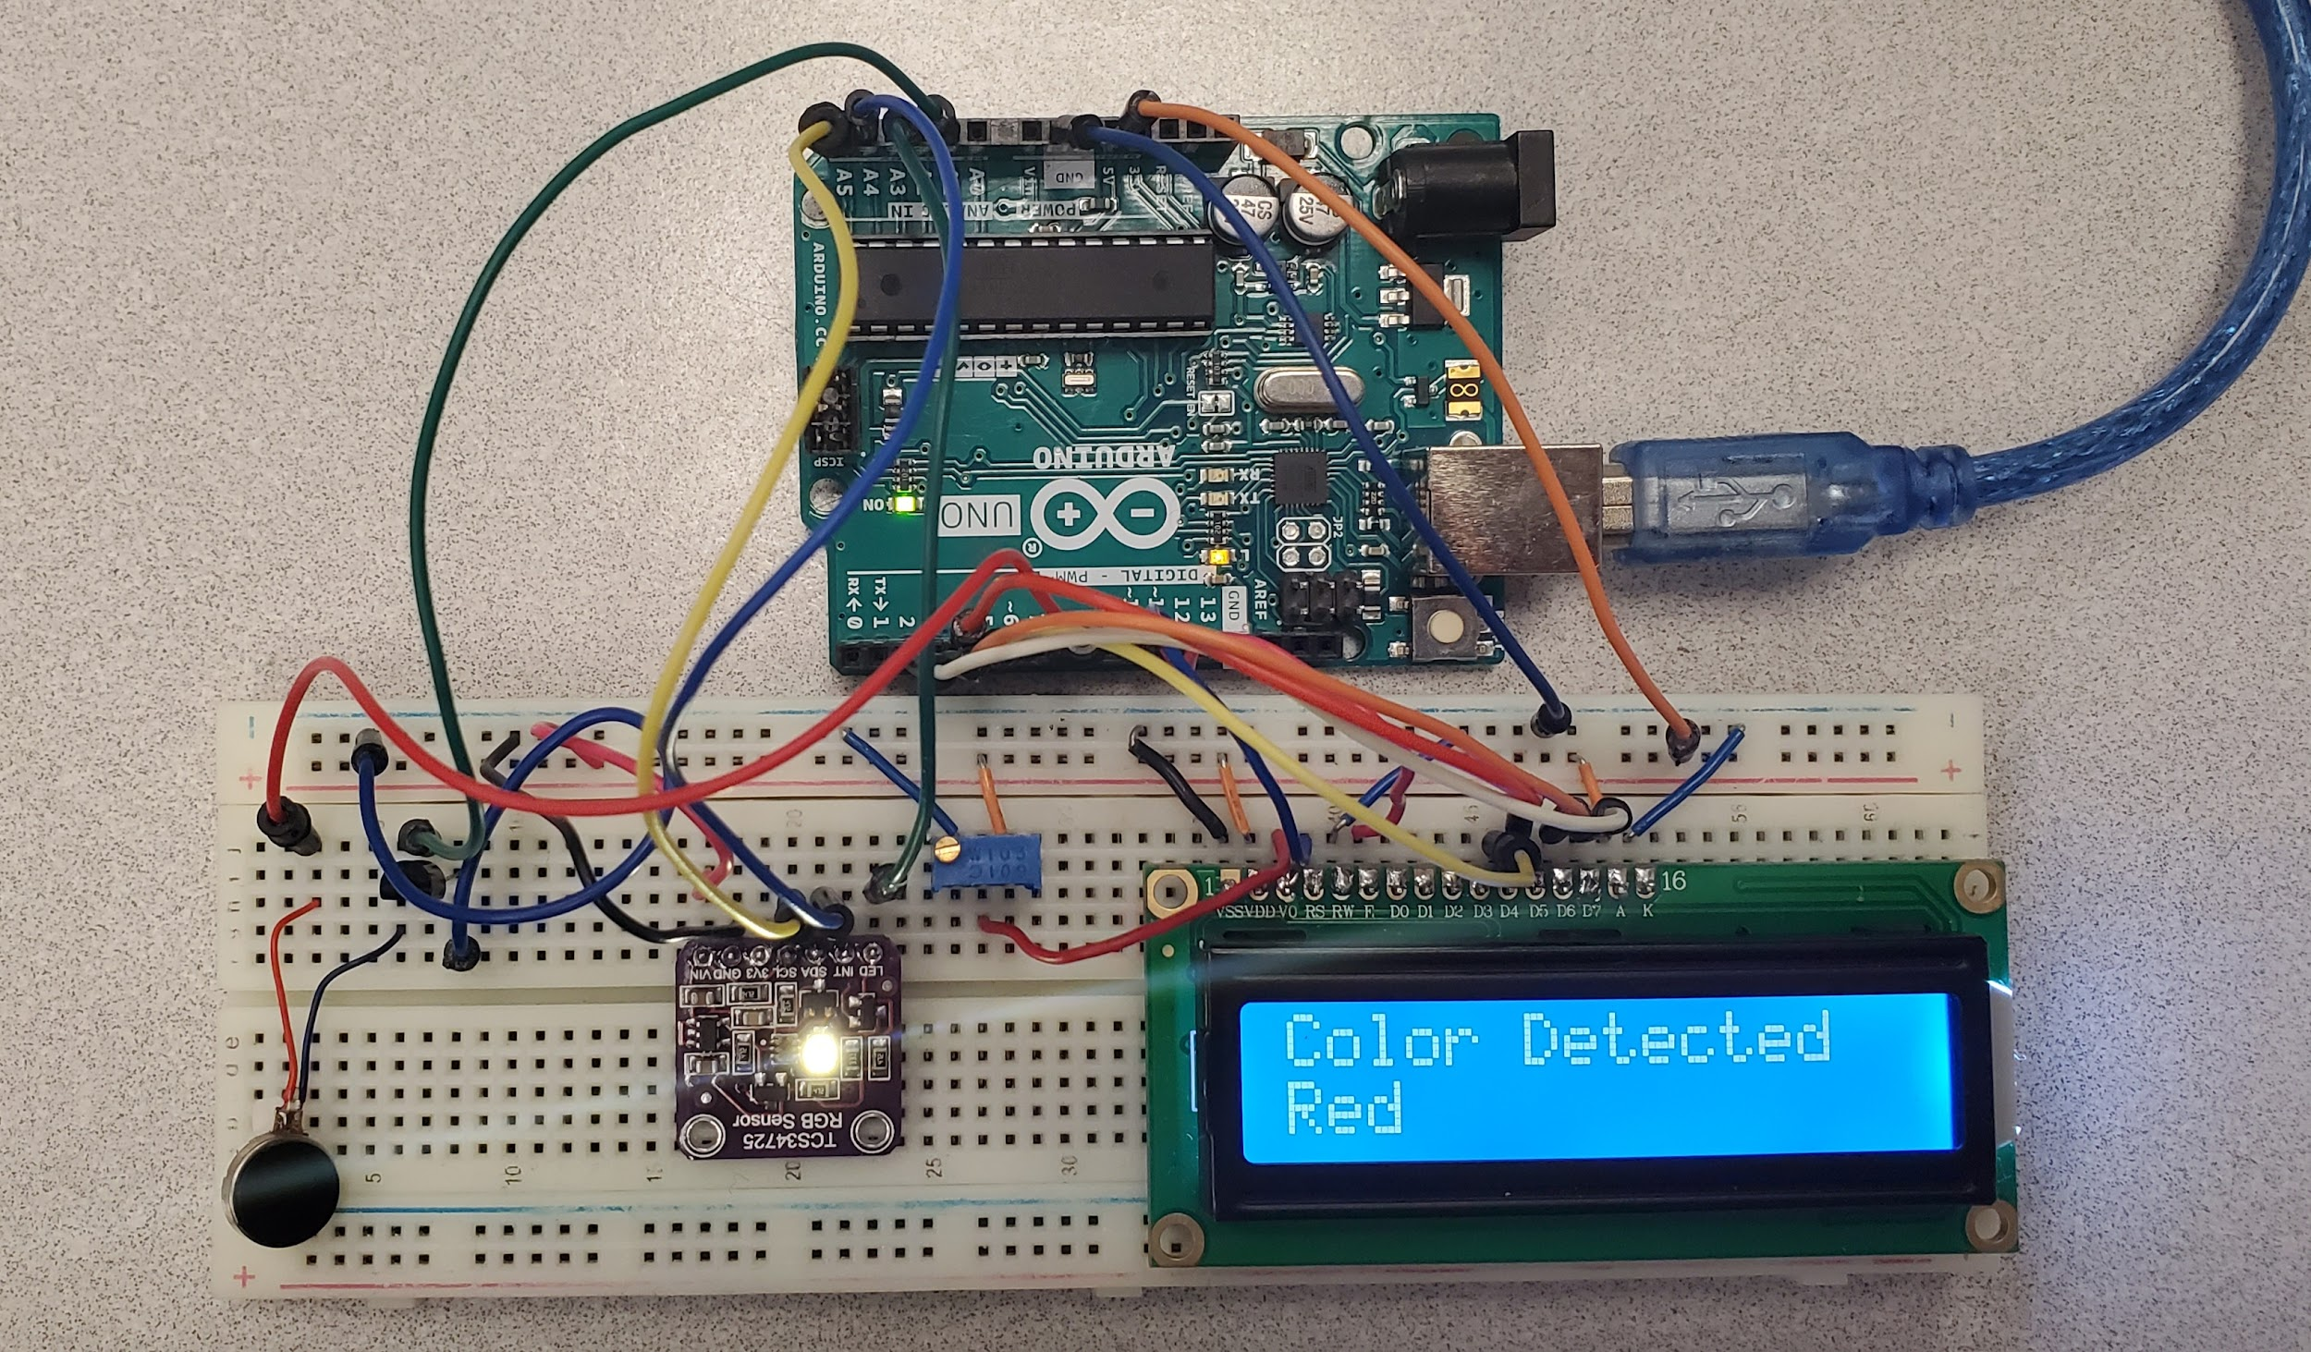

**Discussion**

All components worked as intended with the color displayed on the LCD, and different vibration patterns generated according to the color detected. However, but the vibration was weak, the sensor range was small and only three colors can be detected. For improvement, this prototype is more marketable if it is changed into a wearable device. In terms of ergonomics and comfortability, only vibration feedback should be kept because it is more discreet.

**Code**

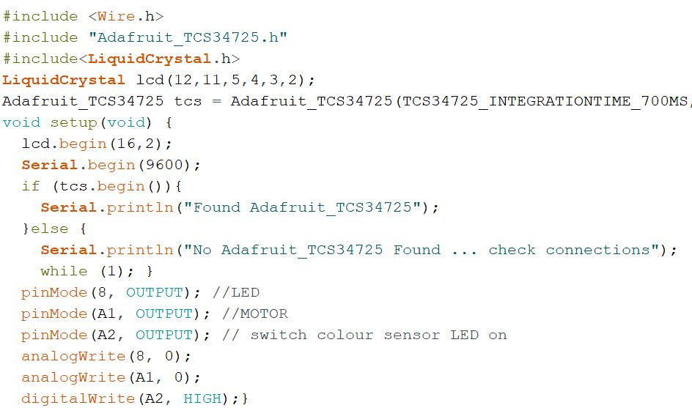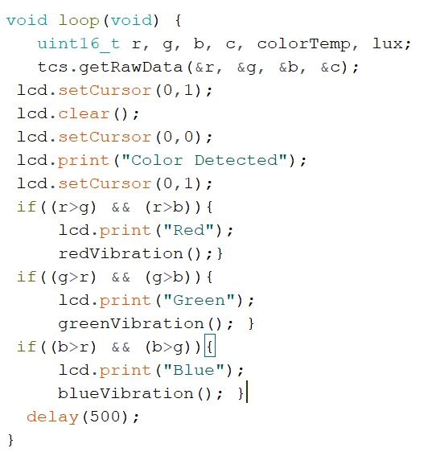

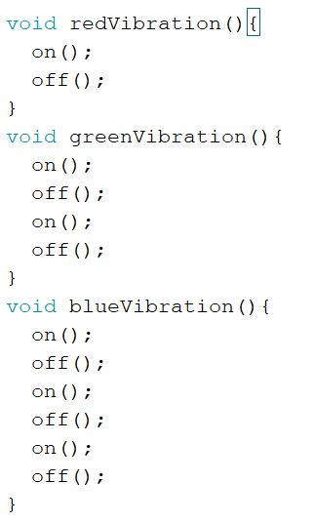 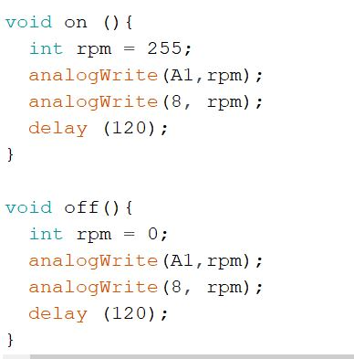

**Source**

“Uzizwe - Colour Ring.” *Arduino Project Hub*,

https://create.arduino.cc/projecthub/uzizwe/uzizwe-colour-ring-9824fb.